**Project Report**

Table of Contents

**Objective 2**

**1. Architecture of the System 3**

* 1. **a. Block diagram of the system**
  2. **b. Explaination the Architecture**

**2. System 5**

* 1. **a. Modules**
  2. **b. module and brief description**
  3. **c. Create, Edit & View Pages**

**3. Technical Rrequirements 7**

**4. Security Requirement 9**

**a. Access level 9**

**b. Login and Logout mechanism 9**

**5. Eclipse Installation 9**

** a. Eclipse Screenshot 10**

** b. Feature of Eclipse used mainly in this project 11**

**6. Coding & Documentation Standards 10**

**Project Background**

Internet is a good place to search about new things or what is trending in the tech industry, but that comes with lots of overhead. You need to deal with annoying ads and search engines are always pushing paid links which are irrelevant to you. Have you tried searching for post or article that solves your problem or addresses the issue in the way you want someone in your position to answer, if you have done that you know that’s annoying and time wasting. Wouldn’t it be better if you can ask question or post polls which will reach to the audience which it was targeted for. To answer the same question and provide this very functionality we have created this project. The aim of the ABC website is to support and enhance the communication medium among the programmer and developer community. As a budding or experienced developer you try to reach out to the people sharing the same skill and mindset and expand your circle or skills.

As a developer who also feels the same need to have centralized way of networking and getting the news about the industry, we have tried to make a space for techies. The project not only focuses on of your networking needs but also it also allows users to post job. Having jobs coming into your feeds keeps you updated about the what’s trending skill that companies are looking for. Showing of your works and project you are working on can also put you radar of the companies looking for particular skill set.

The project is mainly based around users posting threads and jobs but we also feel to add some additional functionality like messaging, commenting on threads and discussion on some particular topic. The project is mainly built on the top of the MVC architecture and uses Struts framework. Struts is a framework which is made with Java programming language that takes care of lots of development aspects of the project so the developer can focus on the main functionality of the project. The project uses basic login and logout functionality which will be updated very soon to have more secure browsing experience. User and website specific data is stored and handled at the back-end with Mysql database. Mysql database is a very reliable and industry tested database that handles relational data.

As we move towards adding more functionality and improving feature the project will be available for the users to use and provide feedback.

**Objective**

The purpose of this application is to provide common space for the programmers belonging to all the fields. Access to job opportunity and communication among peers provides you the ability to network and create social network that helps you to grow and learn new things. The most difficult task comes to you while searching for a job, is to find a contact that can lead you to land job easily. This project tries to solve the task of getting you among the people which share the common knowledge, skills and goal.

This website tries to cater the needs of programmer, developers as well as managing staff. It also provides you the ability to post a job opportunity straight from you profile. People who follow you or interested in the job can access the job posting created by you. For you communication need this project is equipped with messaging ability that can help you to get your queries answered quickly from the comfort of your browser.

As the project focuses on creating space for conversation among it’s user it also tries to pursue users to put forth their work and experience among the community members. Asking questions and creating discussion threads are the main focus of the website to engage users in meaningful conversation. This project not only provides benefit to beginner developer to create the network but also provides experienced ones to get hold of new untouched talent.

Overall the project resolves mostly among the issue of communication and engage user in the conversation which they care about most.

**Architecture of the System**

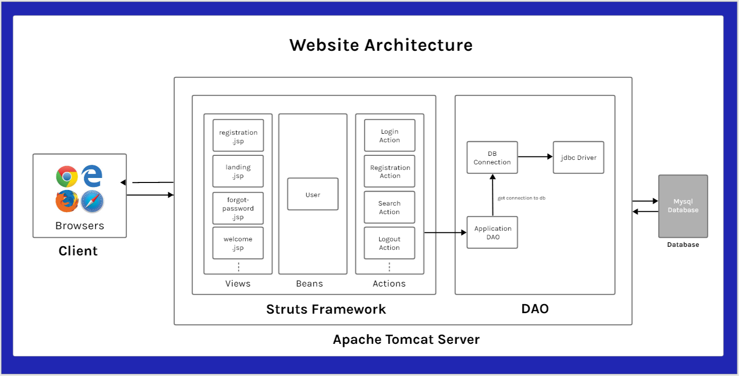

**Block diagram of system**

**Explanation of system architecture**

* The system architecture consists of 3 tier:

1. Client side
2. Server(Apache Tomcat server)
3. Database(Mysql database)

* Client side is basically browser that provides user interface for the website. Interaction is usually done through forms and link.
* Server side consists of a web container which manages life-cycle and state of the app. It handles jsp pages and routing for the application. It also manages request and response object coming from the client.
* We are using Apache Tomcat for deploying our application. The specific version of Apache Tomcat is 7.0.
* Third tier consists of database. Database is responsible for storing the website data. We store user and website specific data in database separated by tables. Each table has it’s own definition and primary key to identify specific relation.
* We are using mysql 5.1 version to store and manage our application.
* We are using Struts framework for front-end as well as back-end integration. Struts is an MVC architecture based framework which is used to develop web-application.
* Business logic is handled by Action classes and DAO layer is responsible for the communication with database.

**System**

* **Modules to be developed:**

1. Login
2. Registration
3. Forgot-password
4. Logout
5. Search user
6. Update profile
7. Messaging

* **Module description**

|  |  |
| --- | --- |
| **Module** | **Description** |
| **Login** | This module provides login facility to the user to log in on website using username and password. Based on information entered by user it allows user to log in into their account or provides prompt if the information is incorrect. |
| **Registration** | This module provides registration facility to the user to register into website. This module provides a form for the user to fill with their basic information. If the information entered is valid user can log in to the system. |
| **Forgot-password** | This module provides the password reset facility to the user. User can use their registered email to reset their password. |
| **Logout** | This module provides the facility to log out of the website and invalidates the current session. |
| **Search user** | This module provides the facility to search other users on the website. |
| **Update profile** | This module provides the facility to the user to update their profile information. |
| **Messaging** | This module provide the functionality to send message among the users. |
| **Post** | This module allows user to post a thread on their profile. |
| **Post job** | This module allows user to post a job on their profile along with job details and requirements. |

* **Create, edit & view pages**

|  |  |
| --- | --- |
| **Create** | Registration, Messaging, Post, Post job |
| **Edit** | Update profile, Forgot password |
| **View** | Search user, Login, Logout |

* **Technical Requirements:**

|  |  |
| --- | --- |
| **Technology** | **Description** |
| **Databases** | This project uses Mysql for storing and management of user and website related data. MySQL is an open-source relational database management system (RDBMS). MySQL is free and open-source software under the terms of the GNU General Public License, and is also available under a variety of proprietary licenses. MySQL is a component of the LAMP web application software stack (and others), which is an acronym for Linux, Apache, MySQL, Perl/PHP/Python. |
| **Programming languages and frameworks** | This project is using HTML, CSS and JavaScript for front-end interface. Java and Java based back-end framework Struts to handle server side interaction. |
| **Web server** | This project runs on Apache Tomcat Server. Apache Tomcat (sometimes simply "Tomcat") is an open-source implementation of the Java Servlet, Java Server Pages, Java Expression Language and WebSocket technologies. Tomcat provides a "pure Java" HTTP web server environment in which Java code can run. Tomcat is developed and maintained by an open community of developers under the auspices of the Apache Software Foundation, released under the Apache License 2.0 license. |
| **Testing Tool** | This project uses JUnit for the testing of the code logic. JUnit is a unit testing framework for the Java programming language. JUnit has been important in the development of test-driven development. JUnit is linked as a JAR at compile-time; the framework resides under package JUnit. |
| **Presentation Tools** | This project uses WPS Office for reporting and presentation purposes. WPS Office is an office suite for Microsoft Windows, macOS, Linux, iOS and Android, developed by Zhuhai-based Chinese software developer Kingsoft. WPS Office is a suite of software which is made up of three primary components: WPS Writer, WPS Presentation, and WPS Spreadsheet.  Axure and Adobe XD is used for the prototyping of the project. Adobe XD is a vector-based user experience design tool for web apps and mobile apps, developed and published by Adobe Inc. While Axure RP Pro / Team is a wire-framing, rapid prototyping, documentation and specification software tool aimed at web, mobile and desktop applications. It offers drag and drop placement, re-sizing, and formatting of widgets. |

* **Security Requirements**
* **Security Access for different kind of users**

|  |  |
| --- | --- |
| **Kind of user** | **Access level** |
| **Regular** | Can access website, change their profile data and can post on thread or job |
| **Admin** | Can access database, can do CRUD operation over the data and takes care of security. |
| **Software Programmer** | Can provide registration and login page and password retrieval. |

* **Login and Logout mechanism**

|  |  |
| --- | --- |
| **Authentication Mechanism** | **Working** |
| **Login** | For the user to login on system, they are presented with login page where they can put in their username and password to get access to their profile. Username and password are then run against database for the match if a match is found user is granted access to their profile. |
| **Logout** | For the user to logout of the system, they are provided with logout option that would be accessible on the top right corner of the website. As user logs out of system their credentials from session are invalidated. |

**Eclipse Installation**

Eclipse Neon is an integrated development environment (IDE) used programming and development. It contains a base workspace and an extensible plug-in system for customizing the environment. Eclipse is used mostly to develop Java applications, but it may also be used to develop applications in other programming languages.

* **Eclipse Screenshot**

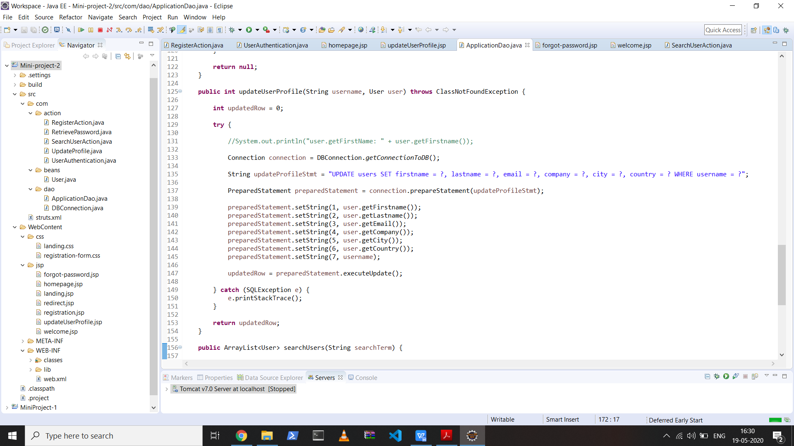

* **Feature of Eclipse used mainly in this project**

An IDE typically contains a code editor, a compiler and a debugger that can be accessed through [some user interface](https://searchwindevelopment.techtarget.com/definition/GUI). The user writes and edits [source code](https://searchapparchitecture.techtarget.com/definition/source-code) in the code editor. The compiler translates the source code into a machine readable language, the debugger can be used to test the working of code by going line by line working of each statement.

An IDE can also contain features such as programmable editors, object and data modeling, [unit testing](https://searchsoftwarequality.techtarget.com/definition/unit-testing), a source code library and build automation tools.

1. **Generate getters and setters**

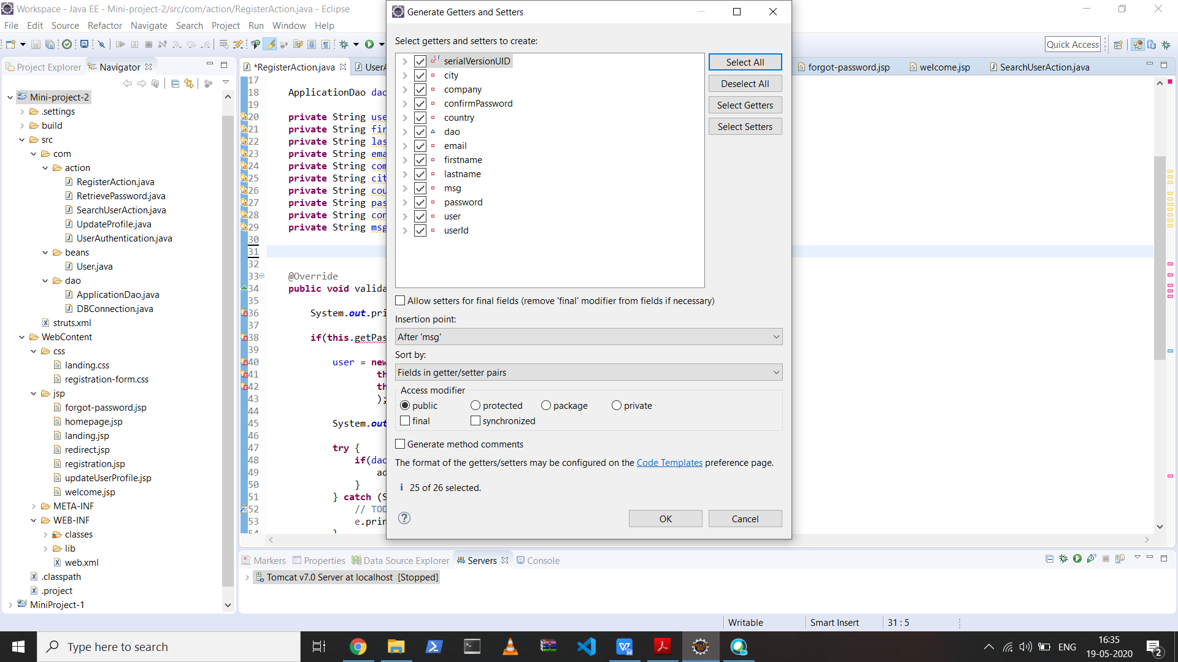

1. **Auto import and import suggestion**

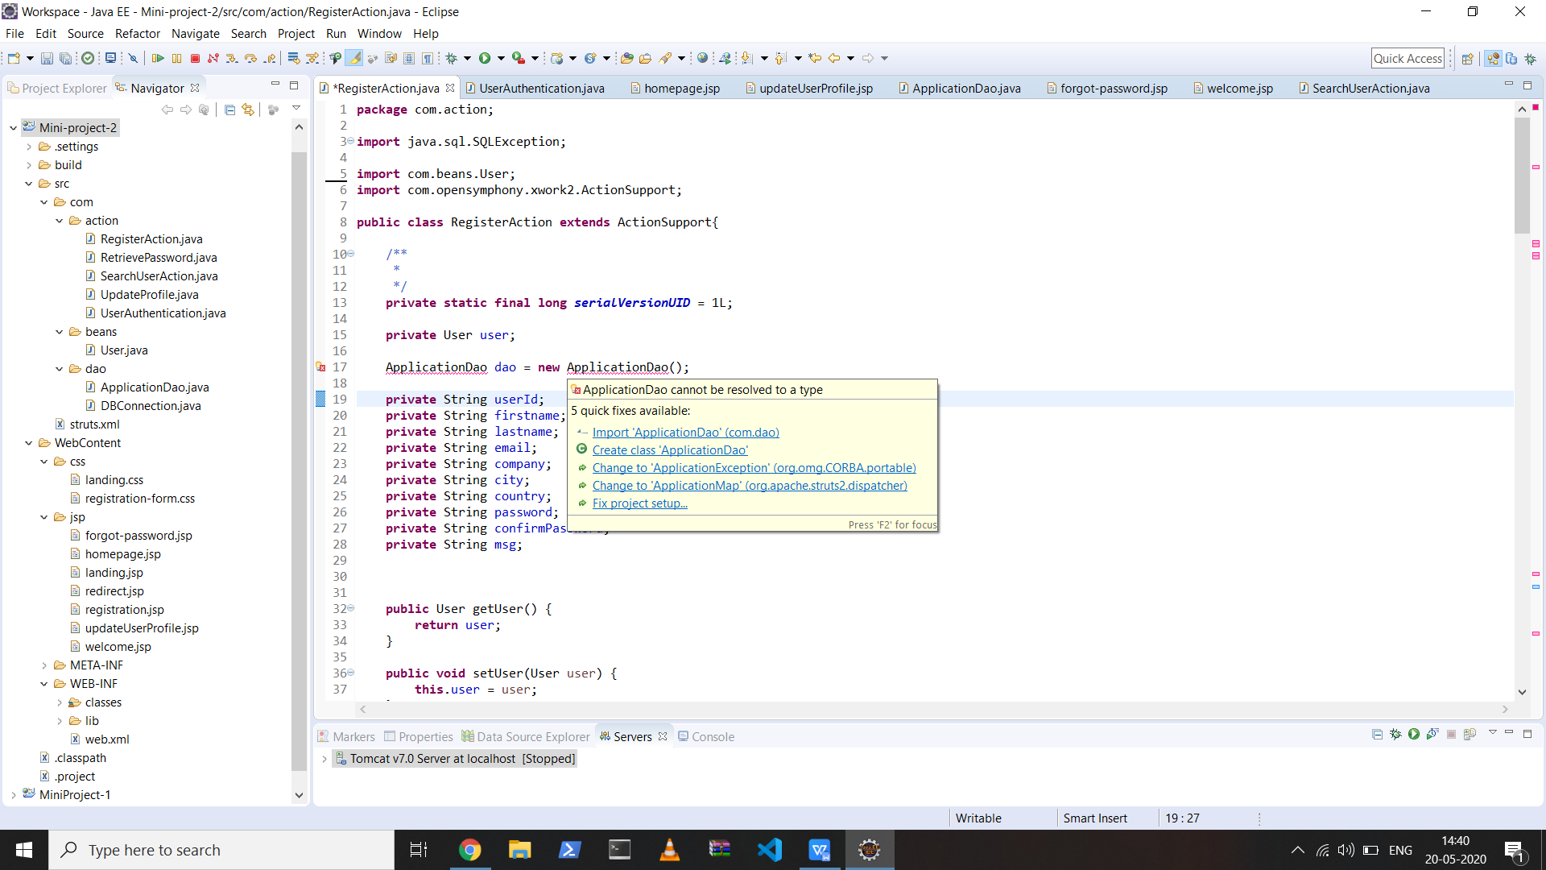

1. **Creating server**

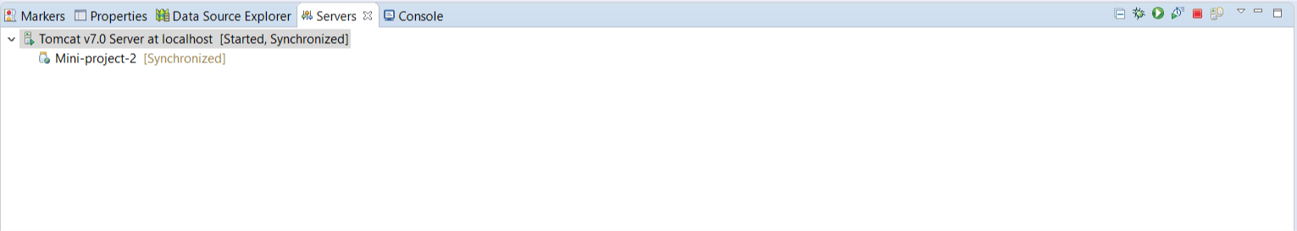

1. **Database development view**

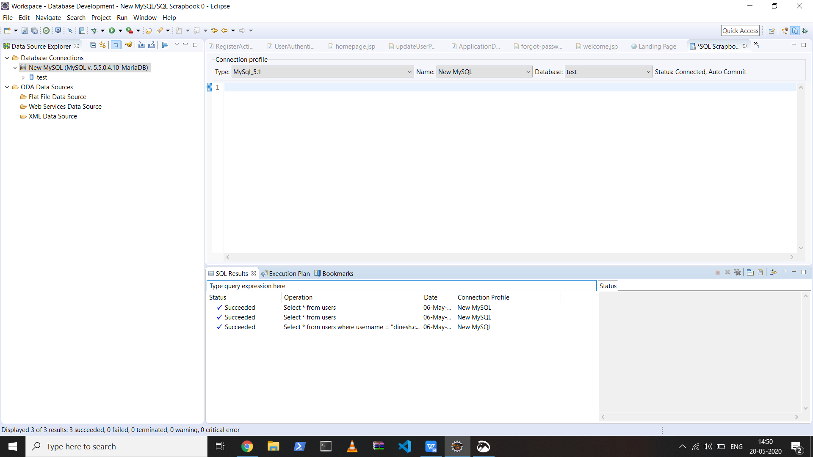

**Coding & Documentation Standards**

Documentation standards in a software project are important because documents are the way of representing the programming process. Consistent appearance, structure makes document easier to read and understand.

Coding standards are a set of guidelines and best practices in programming that should be followed when writing code for the project. They not only make your life easier but also helps the programmer inheriting your project.

1. The source file is organized with documentation comment, package declaration.
2. Class and interface names are CamelCase.
3. Names are in verbs in mixed case with each internal word capitalized.
4. Indentation uses 4 spaces and stays consistent.
5. Declarations and Assignments are declared one per line.